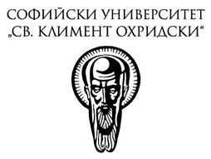

III Sofia “Erasmus” Legal Science Week
“The Role of Courts in Contemporary Legal Orders”
29-30 March 2019
University of Sofia “St. Kliment Ohridski”
Sofia, Bulgaria

Name of the applicant
Institution
Academic position
Summary of the presentation and the paper (300-500 words)

